ONLINE COURSE SCAFFOLDING
Use the scaffolding as a guide for your own course design.
Introduction
The Story (one month prior to the start of class)
The Video (one month prior; post on seminary site)
The Post #1 (one month prior)
The Post#2 (two weeks prior)

About the Professor
Michael A. Milton, PhD
- Faculty Page: https://michaelmilton.org/faculty-page
- About: https://michaelmilton.org/about
- Curriculum Vitae: https://michaelmilton.org/cv
- Books: https://www.amazon.com/-/e/B002SGDA8S

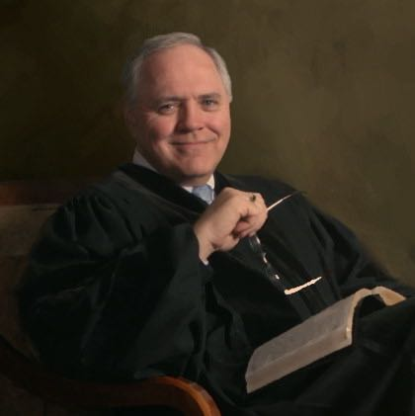

Video
Introduction Video:Welcome
Dr. Michael A. Milton introduces the course by reviewing:
- The Professor
  - Personal
  - Vocational
  - Relationship to the Course
- The Course Overview
- The Expected Student Outcomes
- The Weekly Learning Experience
  - Reading
  - Lecture
  - Mini-examinations
  - Discussion Board
    - Your response to the questions
    - Your response to your peers
  - Weekly Research Paper
    - Turabian
    - With Cover and Bibliography
    - Each week’s paper must have at least
- A Word on “Deeper Learning” through Student Research
Syllabus

Rubrics
Grading Rubrics
Dr. Milton’s Theological Graduate Research Paper Rubric
Dr. Milton’s Homiletic Coaching Rubric
Dr. Milton’s Oral Presentation Rubrics
Online Discussion Rubric

Week 1: Read the assigned text with public reading guidence. Video (mp4 format) to be posted online.
Week 2: Writing an Introduction according to standards. 1 page.
What is the presenting issue in the text? State it in context. State it in universal terms.
Opening statement suggests or states the presenting issue.
Opening illustraiton tells the story of the presenting issue.
Week 4: Write a connection movement. No more than (NMT) 2 pages.
Week 7: Oral message delivered video.
Peer-reivew.
Week 8: Complete expository sermon due.

Week One
Overview Video
Overview paragraph
Reading
Lecture Notes
Devotional Links
Supplemental Material
Deliverables
Module 1: None.
Moduel 2: 3-5 page research paper on “The Public Reading of Scripture;”
Module 3: 3-5 page research paper on “Rhetoric, Ethos, and Pathos;”
Module 4: 3-4 page research paper on “The Introduction Movement: From Opening Sentence to Transition;”
Module 5: 3-4 page research paper on “The Exegetical Movement: From Statement to Transition.”
Module 6: 3-4 page research paper on “The Expository Movement: From Statement to Transition”
Module 6: Group exercise: Peer-review of the Expository Movement paper. Each student will download one other paper, annotate it according to the Expository Model and upload as an assignment. The professor will return the papers to the students.
Module 7: 3-4 page research paper on “The Main Argument: From Transitional Statement with Key Word(s) to the Final Arguement Transition;”
Module 8: 3-4 page research paper on “The Closing Argument: From Statement to Final Appeal.”

Pre Course Survey

Due Mar Monday noon in Weed 2
Points 0
Questions 10
Time Limit 30 Minutes
Instructions
Please complete this prior to reading any of the course materials, including the module notes, and before you begin participating in the Module One discussions or other learning activities. This Pre-Course Survey is not graded, but it is important that you complete it. This survey will be used exclusively to establish a baseline of your knowledge about the course subject material prior to taking this course. Your results will be kept confidential between you and your instructor and will be used by you near the end of the course as part of your self-reflection assignment. Average results for the class as a whole will be tracked in aggregate to help evaluate course materials and assignments; your individual results will only be viewed by you and your instructor, and they have no bearing of any kind on your overall grade in this course.
Survey Information:
The Pre-Course Survey is your resource in that it gives you a base-line of self-understanding about the subject. During the post-course reflection you take a Post-Course Survey. The results are yours and intended to measure progress in your degree. The Pre and Post Course Surveys allow the Professor and the Institution to consider our assessement of outcomes. The surveys provide an opportunity for instituteional effectiveness and improvement.
Rating Scale:
1 - No knowledge or understanding
2 - Very basic knowledge or understanding
3 - Sufficient knowledge or understanding
4 - Strong knowledge or understanding
The Pre-Course Survey is here:
The Post-Course Survey is here: https://milton903715.typeform.com/to/jpGdEd

The Lecture of the week: recorded or live.

Be sure to view this video from Dr. Billy Graham on “Technology and Faith.”
Link: https://www.ted.com/talks/billy_graham_on_technology_and_faith?utm_campaign=tedspread&utm_medium=referral&utm_source=tedcomshare
Embed:
<div style="max-width:854px"><div style="position:relative;height:0;padding-bottom:56.25%"><iframe src="https://embed.ted.com/talks/billy_graham_on_technology_and_faith" width="854" height="480" style="position:absolute;left:0;top:0;width:100%;height:100%" frameborder="0" scrolling="no" allowfullscreen></iframe></div></div>

[One can use the Learning Management System (LMS) in order to tally scores with the rest of the grades posted for the course. However, everything must begin in the mind of the course designer-faculty member.

1. The Scripture reading should include a liturgical prelude and postlude. Why?
A. To draw attention.
B. To ascribe glory.
C. To call for reverence.
D. All of the Above
[Note: Your work will, generally, go to the Department of Online Learning, or its equivilent. So, you should BOLD the answer that is correct. The Online Support staff are able to, then, have a “key” as well as the product they will post to the LMS.]

Two questions to build the pillars of online education:
- Student to Content
- Student to Student
- Student to Faculty
- Student to Community
Questions should be:
- Designed to build the four pillars.
- Designed for open-ended questions.
- In STEM, may be designed for processing, researching, or, working out, e.g., a mathematic problem.
Student Requirement: Two replies that demonstrate scholarly reflection and critical thinking.
- Using Discussion Board ettiquette
- Offering substantive discussions beyond the mere “great job” response.
- See the rubric: Online Discussion Rubric

Research Paper Guide
The presenting issue or question is stated.
The weekly research paper should demonstrate scholarship that reflects theological reflection, critical thinking, and conclusion(s).
The weekly research paper will follow Turabian guidelines.
The weekly research paper will be at least two pages and not more than three pages, plus the cover sheet and the bibliography.
The weekly research paper will include citations for major assertions. At least two citations will be from peer-reveiwed journal articles.
All footnotes will be reflected in the bibliography along with any other items of reference, whether digital, paper, or verbal. See Turabian guidelines for proper citation.
Use of a citation manager (e.g., Endnote, Zotero) is highly recommended. Make sure the settings are for Turabian.

Week Two
Overview
Reading
Lecture Notes
Devotional Links
Supplemental Material

Link to the Course sample Welcome.

The Lecture of the week: recorded or live.

Research Paper Guide
The presenting issue or question is stated.
The weekly research paper should demonstrate scholarship that reflects theological reflection, critical thinking, and conclusion(s).
The weekly research paper will follow Turabian guidelines.
The weekly research paper will be at least two pages and not more than three pages, plus the cover sheet and the bibliography.
The weekly research paper will include citations for major assertions. At least two citations will be from peer-reveiwed journal articles.
All footnotes will be reflected in the bibliography along with any other items of reference, whether digital, paper, or verbal. See Turabian guidelines for proper citation.
Use of a citation manager (e.g., Endnote, Zotero) is highly recommended. Make sure the settings are for Turabian.

Week Three
Overview
Reading
Lecture Notes
Devotional Links
Supplemental Material

The Lecture of the week: recorded or live.

Research Paper Guide
The presenting issue or question is stated.
The weekly research paper should demonstrate scholarship that reflects theological reflection, critical thinking, and conclusion(s).
The weekly research paper will follow Turabian guidelines.
The weekly research paper will be at least two pages and not more than three pages, plus the cover sheet and the bibliography.
The weekly research paper will include citations for major assertions. At least two citations will be from peer-reveiwed journal articles.
All footnotes will be reflected in the bibliography along with any other items of reference, whether digital, paper, or verbal. See Turabian guidelines for proper citation.
Use of a citation manager (e.g., Endnote, Zotero) is highly recommended. Make sure the settings are for Turabian.

Week Four
Overview
Reading
Lecture Notes
Devotional Links
Supplemental Material

The Link to the video lecture of the week:

Research Paper Guide
The presenting issue or question is stated.
The weekly research paper should demonstrate scholarship that reflects theological reflection, critical thinking, and conclusion(s).
The weekly research paper will follow Turabian guidelines.
The weekly research paper will be at least two pages and not more than three pages, plus the cover sheet and the bibliography.
The weekly research paper will include citations for major assertions. At least two citations will be from peer-reveiwed journal articles.
All footnotes will be reflected in the bibliography along with any other items of reference, whether digital, paper, or verbal. See Turabian guidelines for proper citation.
Use of a citation manager (e.g., Endnote, Zotero) is highly recommended. Make sure the settings are for Turabian.

Week Five
Overview
Reading
Lecture Notes
Devotional Links
Supplemental Material

The Link to the video lecture of the week:

Research Paper Guide
The presenting issue or question is stated.
The weekly research paper should demonstrate scholarship that reflects theological reflection, critical thinking, and conclusion(s).
The weekly research paper will follow Turabian guidelines.
The weekly research paper will be at least two pages and not more than three pages, plus the cover sheet and the bibliography.
The weekly research paper will include citations for major assertions. At least two citations will be from peer-reveiwed journal articles.
All footnotes will be reflected in the bibliography along with any other items of reference, whether digital, paper, or verbal. See Turabian guidelines for proper citation.
Use of a citation manager (e.g., Endnote, Zotero) is highly recommended. Make sure the settings are for Turabian.

Week Six
Overview
Reading
Lecture Notes
Devotional Links
Supplemental Material

The Link to the video lecture of the week:

Research Paper Guide
The presenting issue or question is stated.
The weekly research paper should demonstrate scholarship that reflects theological reflection, critical thinking, and conclusion(s).
The weekly research paper will follow Turabian guidelines.
The weekly research paper will be at least two pages and not more than three pages, plus the cover sheet and the bibliography.
The weekly research paper will include citations for major assertions. At least two citations will be from peer-reveiwed journal articles.
All footnotes will be reflected in the bibliography along with any other items of reference, whether digital, paper, or verbal. See Turabian guidelines for proper citation.
Use of a citation manager (e.g., Endnote, Zotero) is highly recommended. Make sure the settings are for Turabian.

Week Seven
Overview
Reading
Lecture Notes
Devotional Links
Supplemental Material

The Link to the video lecture of the week:

Research Paper Guide
The presenting issue or question is stated.
The weekly research paper should demonstrate scholarship that reflects theological reflection, critical thinking, and conclusion(s).
The weekly research paper will follow Turabian guidelines.
The weekly research paper will be at least two pages and not more than three pages, plus the cover sheet and the bibliography.
The weekly research paper will include citations for major assertions. At least two citations will be from peer-reveiwed journal articles.
All footnotes will be reflected in the bibliography along with any other items of reference, whether digital, paper, or verbal. See Turabian guidelines for proper citation.
Use of a citation manager (e.g., Endnote, Zotero) is highly recommended. Make sure the settings are for Turabian.

Week Eight
Overview
Reading
Lecture Notes
Devotional Links
Supplemental Material

The Link to the video lecture of the week:

Two questions
Keep the four pillars in mind

Research Paper Guide
The presenting issue or question is stated.
The weekly research paper should demonstrate scholarship that reflects theological reflection, critical thinking, and conclusion(s).
The weekly research paper will follow Turabian guidelines.
The weekly research paper will be at least two pages and not more than three pages, plus the cover sheet and the bibliography.
The weekly research paper will include citations for major assertions. At least two citations will be from peer-reveiwed journal articles.
All footnotes will be reflected in the bibliography along with any other items of reference, whether digital, paper, or verbal. See Turabian guidelines for proper citation.
Use of a citation manager (e.g., Endnote, Zotero) is highly recommended. Make sure the settings are for Turabian.

Appendix
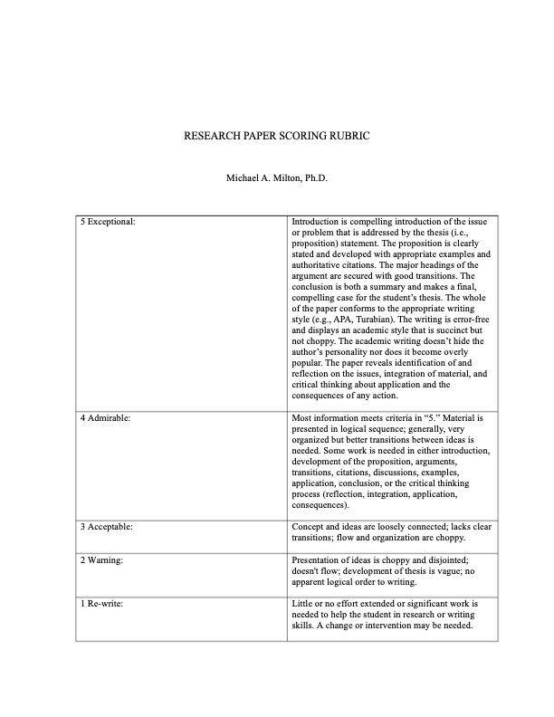

Final Paper Guidelines
Using the organizational structure (e.g., Burden, Values, Vision, and so forth) in Milton’s Finding a Vision for Your Church: Assembly Required, prepare a “Church Planting Mission Plan” for a city in North America. The “Burden” will introduce your reason for selecting the respective metropolitan (or rural or urban) area. Demographic data, news articles, books, and other authoritative material will be cited in your rationale for selecting the city.
The Church Planting Mission Plan will demonstrate a spiritual need for the proposed church, as well as why the values, vision, mission, etc., is shaped accordingly.
*For students in a Master degree program: Your paper will be 8-10 pages plus cover and bibliography.
**For students in the Doctor of Ministry program: Your paper will be 12-15 pages plus cover and bibliography.
***D.Min. students will also provide a 3-5 page review of one of the books that you read for the course to include:
- The thesis of the work
- Your response to the work
- Practical application for the subject of this course.
Peer-reviewed journal articles are not necessary for the book review. At least two citations, however, will support your observations and conclusions. These may be other reviews, comparison of other works, or other authoritative citations.

Resource Links for the Course

Resources for Theology Papers, Etc.

Johnson, Marshall D. “A Short Guide to Writing Research Papers in Biblical Studies and Theology” (n.d.): 16.
Trupiano, Rose. “Research Guides: Theology & Religious Studies: Article Search.” Accessed May 24, 2018. https://libguides.marquette.edu/c.php?g=36663&p=232883.
“A Brief Guide for Writing Theological Reflection Papers.” Michael Milton, August 13, 2014. Accessed May 24, 2018. http://michaelmilton.org/2014/08/13/a-brief-guide-for-writing-theological-reflection-papers/.
“Books on Writing” n.d. Accessed May 24, 2018. https://divinity.duke.edu/sites/divinity.duke.edu/files/documents/writing-center/Books%20on%20Writing.pdf.
“Find Information.” Accessed May 24, 2018. http://www.erskine.edu/library/find-information/.
“Google Scholar.” Accessed May 24, 2018. https://scholar.google.com/.
“How to Recognize Peer-Reviewed Journals.” Accessed May 24, 2018. http://www.angelo.edu/services/library/handouts/peerrev.php.
“How to Write a Theological Paper (John M. Frame).” Accessed May 24, 2018. http://www.proginosko.com/docs/frame_theol_paper.html.
“Johnson - A Short Guide to Writing Research Papers…” n.d. Accessed May 24, 2018. http://store.fortresspress.com/media/downloads/0800663489Researchguide.pdf.
“Michael A Milton, PhD | Erskine College and Theological Seminary - Academia.Edu.” Accessed May 24, 2018. http://erskineseminary.academia.edu/MichaelMilton.
“Resource Links for Theology and Religious Studies.” Michael Milton, March 10, 2007. Accessed May 24, 2018. http://michaelmilton.org/reformed-and-evangelical-links-2/.
“Seven Questions about Books, Life, and Ministry with Michael Milton.” Servants of Grace. Last modified September 27, 2017. Accessed May 24, 2018. http://servantsofgrace.org/seven-questions-books-life-ministry-michael-milton/.
“What Is A Peer-Reviewed Article? - Evaluating Information Sources - LibGuides at John Jay College of Criminal Justice, CUNY.” Accessed May 24, 2018. http://guides.lib.jjay.cuny.edu/c.php?g=288333&p=1922599.
“What Is Theological Reflection and Critical Thinking and How Do I Use It in a Graduate-Level Research Paper?” Michael Milton, October 30, 2017. Accessed May 24, 2018. http://michaelmilton.org/2017/10/30/what-is-theological-reflection-and-critical-thinking-and-how-do-i-use-it-in-a-graduate-level-research-paper/.
“Writing the Weekly Research Paper.” Michael Milton, July 24, 2016. Accessed May 24, 2018. http://michaelmilton.org/2016/07/24/writing-the-weekly-research-paper/.

Post-Course Survey
[Example only]

Due Mar Monday noon in Weed 2
Points 0
Questions 10
Time Limit 30 Minutes
Instructions
Please complete after uploading your final assignment. This Post-Course Survey is not graded, but it is important that you complete it. This survey will be used exclusively to establish a measurment of your knowledge gained about the course subject material after taking this course. Your results will be kept confidential between you and your instructor. Ordinal results will be shared with the Director of Institutional Effectivenss as a way of improving our content and delivery.
Survey Information:
The Post-Course Survey is your resource in that it gives you a base-line of self-understanding about the subject. During the post-course reflection you take a Post-Course Survey. The results are yours and intended to measure progress in your degree. The Pre and Post Course Surveys allow the Professor and the Institution to consider our assessement of outcomes. The surveys provide an opportunity for instituteional effectiveness and improvement.
Rating Scale:
1 - No knowledge or understanding
2 - Very basic knowledge or understanding
3 - Sufficient knowledge or understanding
4 - Strong knowledge or understanding
The Pre-Course Survey is here:
The Post-Course Survey is here: https://milton903715.typeform.com/to/jpGdEd

The Four Pillars that Support Online Teaching and Learning (Berkely, 2020)
- All content is aimed to connect Student to Content.
- All content is aimed to connect Student to Professor.
- All content is aimed to connect Student to Student.
- All content is aimed to connect Student to Community.
Reference
Berkeley Law Online Courses (2020). University of California Berkley Law School. Retrieved May 7, 2020.

